ConfigFileApllicationListener:管理application.properites或者application.yml

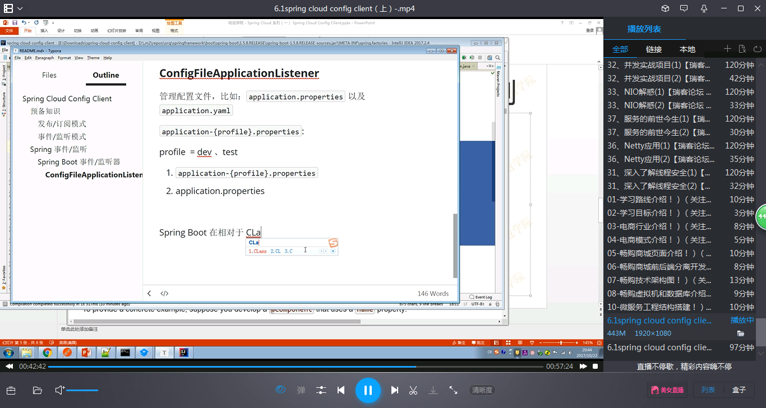



BootstrapApplicationListener:负者加载bootstrap.properties或者yaml